

**Paaress PERfumes**



**THIS IS TO CERTIFY THAT**

**Hasnain Ali**

**HAS SUCCESSFULLY DESIGNED AND DEVELOPED**

**PAARESS PERFUMES**

**SUBMITTED BY**

**HASNAIN ALI**

**DATE OF ISSUE: 15, March 2023**

**DATE OF SUBMIT: 15, April 2023**









**TABLE OF CONTENT OR INDEX**

|  |  |  |
| --- | --- | --- |
| **S.NO** | **CONTENT** | **PAGE NO** |
| **1** | **AKNOWLEDGEMENT** | **1** |
| **2** | **SYPNOPSIS** | **2** |
| **3** | **PROBLEM DEFINATION** | **3** |
| **4** | **PROJECT OBJECTIVES** | **4** |
| **5** | **HARDWARE REQUIREMENTS** | **5** |
| **6** | **SOFTWARE REQUIREMENTS** | **6** |
| **7** | **WORK BREAK DOWN CHART** | **7** |
| **8** | **SCREENSHOTS OF WEBSITE** | **8** -**TO- 21** |
| **9** | **SAMPLE VALIDATION** | **22** |
| **10** | **CHEKLIST** | **23** |

**01**

**AKNOWLEDGEMENT**

**I would like to acknowledge all those who have given morals support and helped me make the project a success.**

**I wish to express my gratitude to the E-Projects Team at the head Office, who guided and helped me. I would also like to express my gratitude to all the staff members of center as well as my class teacher for not only providing me with the opportunity to work with them on this project, but also for their support and encouragement throughout the process.**

**I also express my sincere gratitude to the E-Project Team at the Aptech Head Office and my project guide at the organization, for his valuable guidance and support for the completion of this project.**

**And finally, I would like to offer many thanks to all my colleagues for their valuable suggestion and constructive feedback.**

**02**

**SYPNOPSIS**

* **Paaress Perfumes: It allows customers to quickly view the details of their desired destination site**
* **Paaress Perfumes: It allows customers to quickly view the details of their desired destination site**
* **Paaress Perfumes: It also allows the customer to Mentally Prepared from different plat forms**
* **The web application can be similar to** **https://glowing.g5plus.net/main/home-06/** **through it can be much simpler in functionality. The Informative page on this site can give an idea of how and what to design.**

**PROBLEM DEFINATION**

**03**

**Requirement Specification:**

**The Website is to be created based on the following requirements.**

**PAARESS PERFUMES**

Paarees Perfumes is selling various Perfumes from different brands. The company advertises by distributing the pamphlets, advertising on television and so on. Due to rapid development in internet field, the company decides to launch a website where people will get all the information about the various products available with them easily.

**Requirement Specification:**

The Web site is to be created based on the following requirements.

1. The Home Page should be created with proper sections, graphics and with a suitable logo
2. The site should display a menu which will contain the options for brief introduction about the various products available, location of the shop and any other information if required.
3. The information should be categorized according to different brands like if a User wants to see only ‘Davidoff Perfumes’ then he clicks on a Link/button/menu etc. and he will see all Davidoff Perfumes. Similarly, for ‘Dior’, ‘CK’ and other brands.
4. User can choose between Ladies, Gents or Common Perfumes.
5. A brief summary of details of individual products should be displayed on the Web Page along with the product but detailed Features should be stored in Individual Word documents which can be downloaded or viewed by the User who wishes to see the same.
6. Price List should be available for download.
7. There should be a “Contact Us” page which will have the Address of the Company which is as follows and the mail address which when clicked will invoke the local mail client from where they can send an email.

**PROJECT OBJECTIVE**

**The Objective of this program is to give a sample project to work on real life projects. These applications help you build a larger more robust application.**

**The objective is not to teach you JavaScript/Dreamweaver but to provide you with a real-life scenario and help you create basic applications using the tools.**

**You can revise the chapters before you start with the project.**

This project is meant for students who have completed the module of ***Dreamweaver***. These programs should be done in the Lab sessions with assistance of the faculty if required.

It is very essential that a student has a clear understanding of the subject. Students should go through the project and solve the assignments as per requirements given.

Kindly get back to eProjects Team in case of any doubts regarding the application or its objectives.

**04**

**INPUT PROVIDED BY CLIENT**

* **Input to the existing system**
* **Process involved in the application**
* **Expected delivery dates**
* **List of deliverables**
* **Compare section**

**HARDWARE REQUIREMENTS**

* **A minimum computer system that will help you access all the tools in the courses is a Pentium 166 or better**
* **64 Megabytes of RAM or better**

**05**

**07**

**SOFTWARE REQUIREMENTS**

* **Notepad/HTML editor**
* **Dreamweaver**
* **IE 5.0/ Netscape 6.0**

**08**

**WORK BREAK BREAKDOWN CHART**

|  |  |  |
| --- | --- | --- |
| PHASES | TIME IS DAYS | TEAM MEMBER |
| ANALYSIS | FIVE DAYS | Hasnain Ali |
| PLANNING | FIVE DAYS | Hasnain Ali |
| DESIGNING | SEVEN DAYS | Hasnain Ali |
| IMPLEMNTATION | TEN DAYS | Hasnain Ali |
| TESTING | THREE DAYS | Hasnain Ali |

**09**

**SCREEN SHOTS FROM HERE**

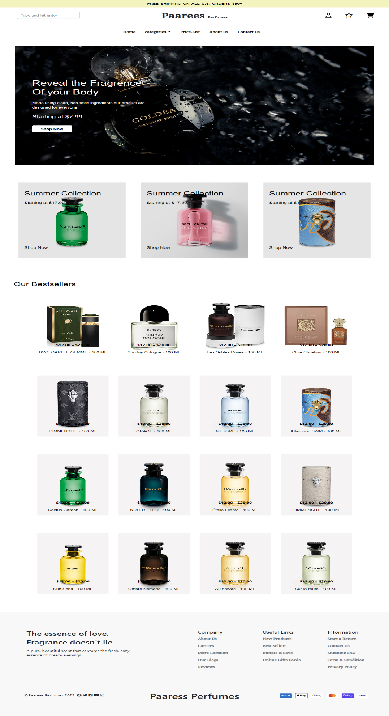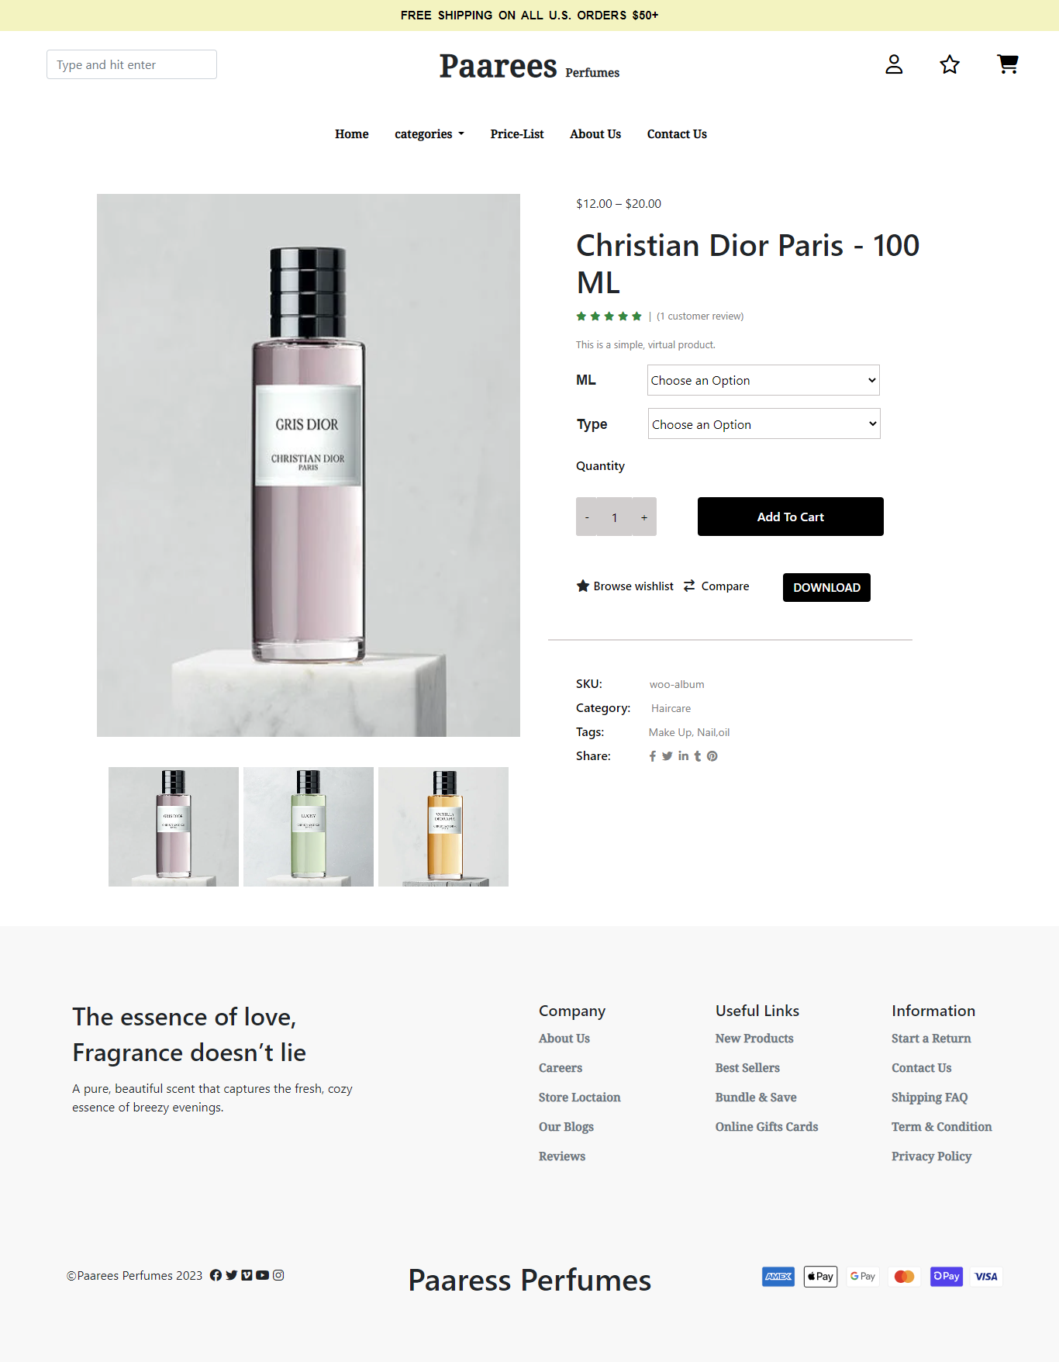

**10**

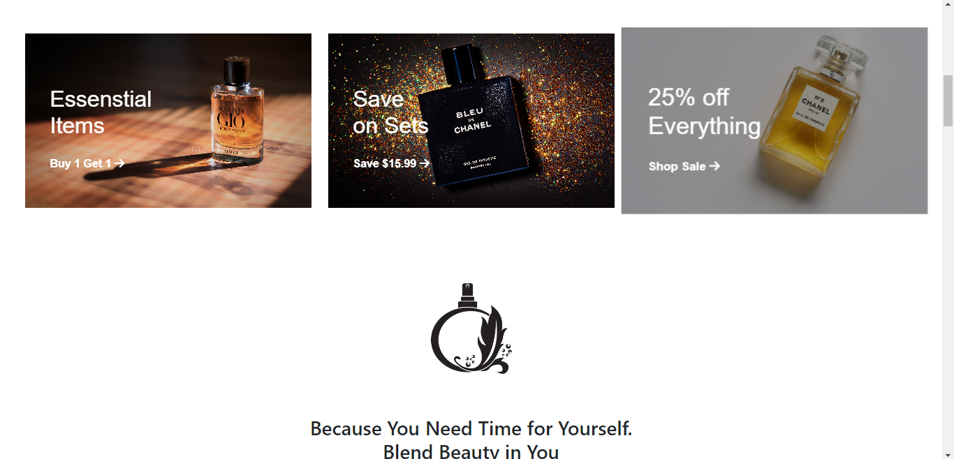

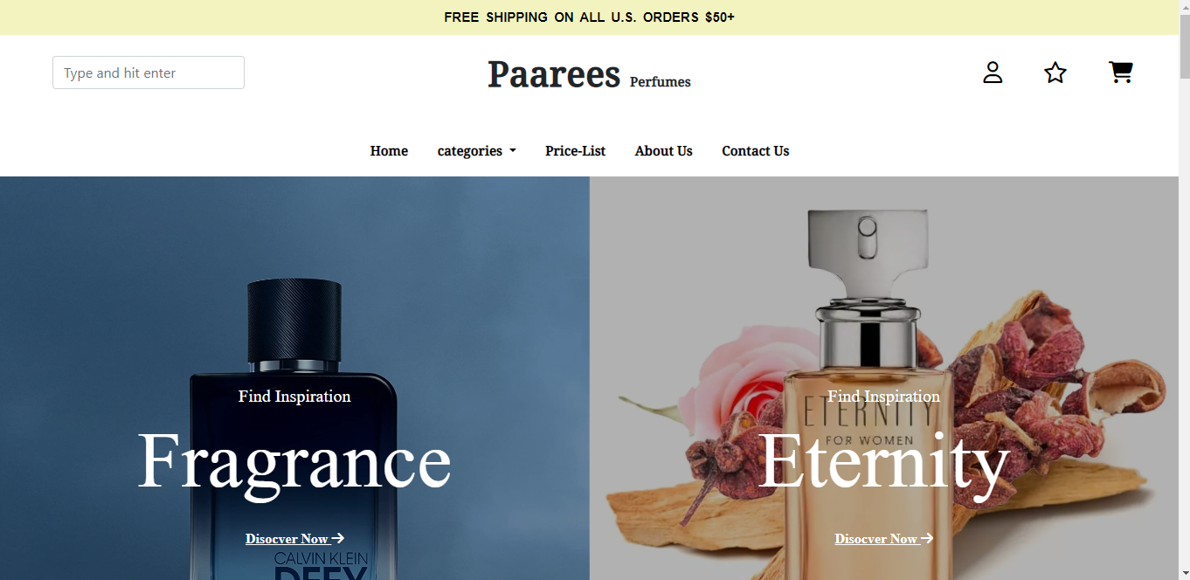

**11**

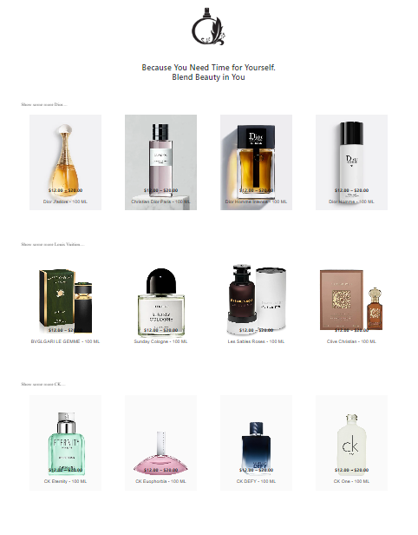

**12**

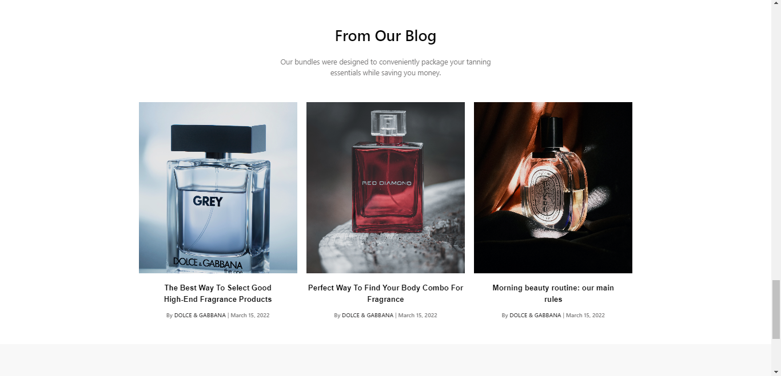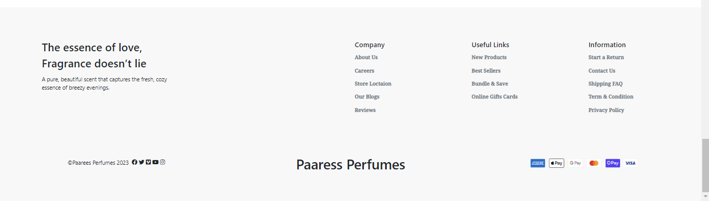

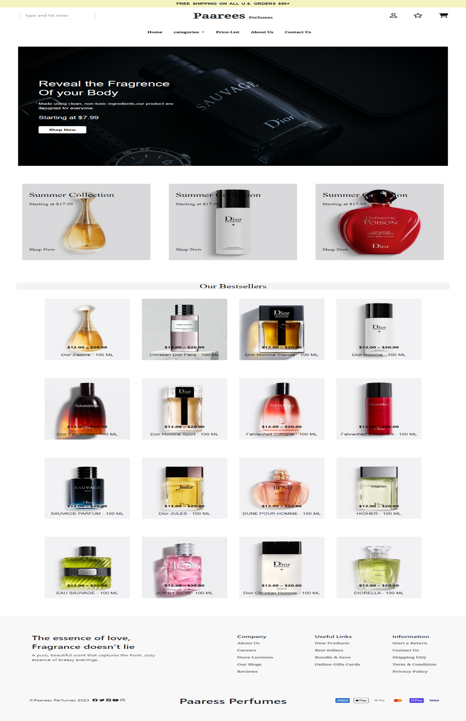

**13**

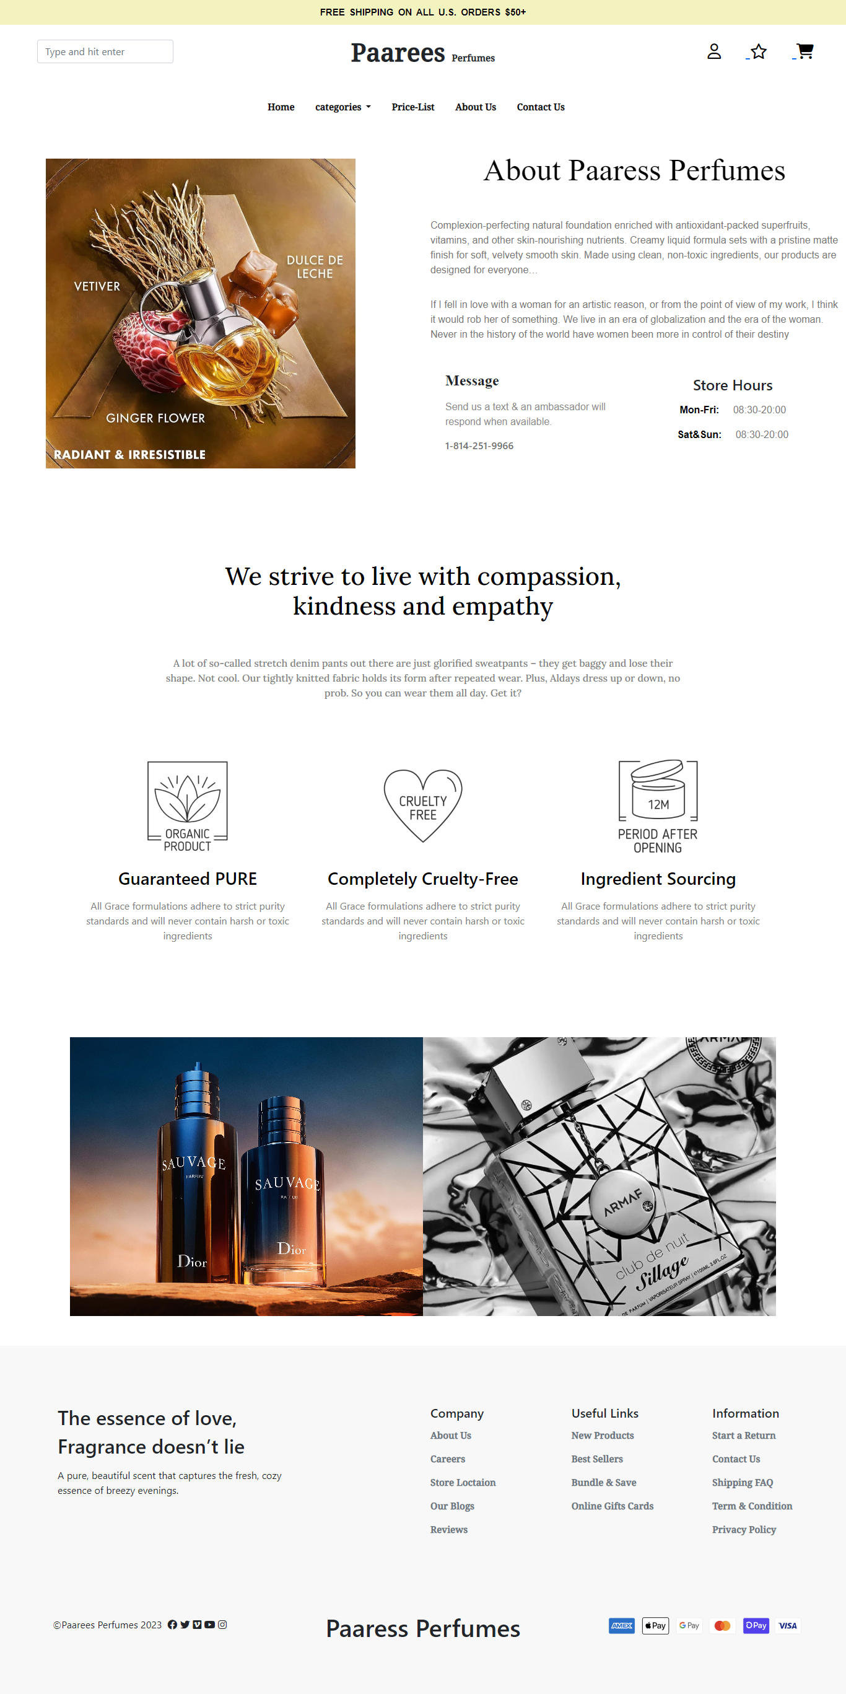

**14**

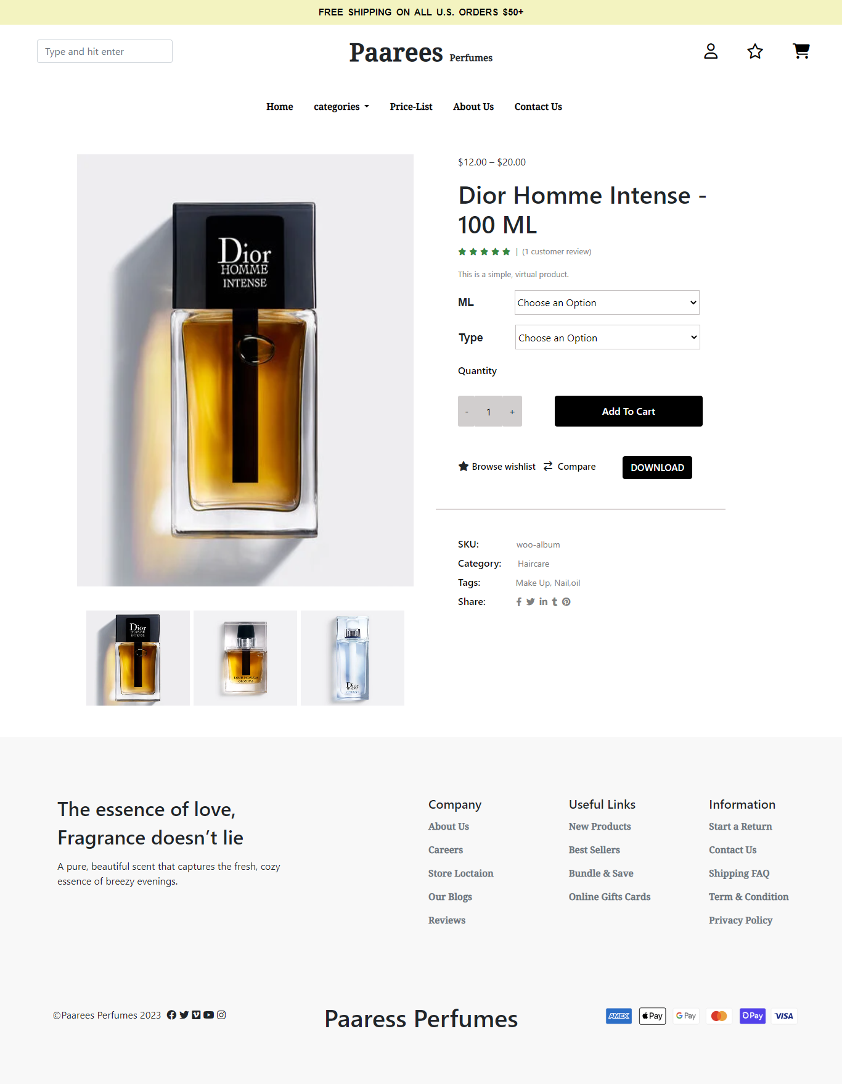

**15**

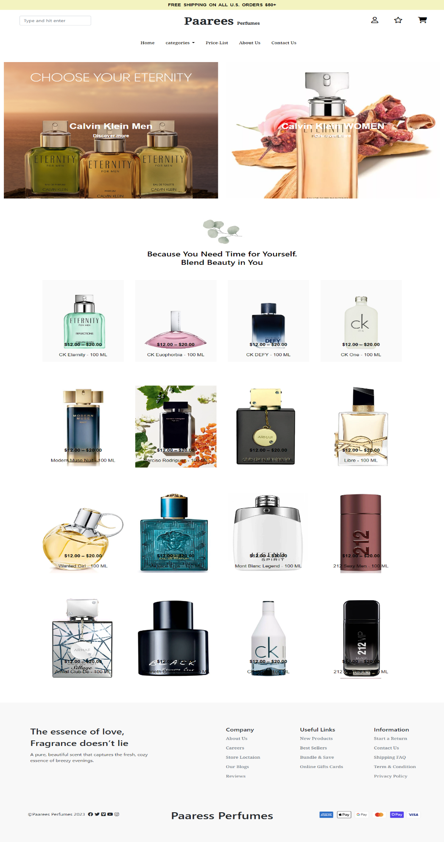

**16**

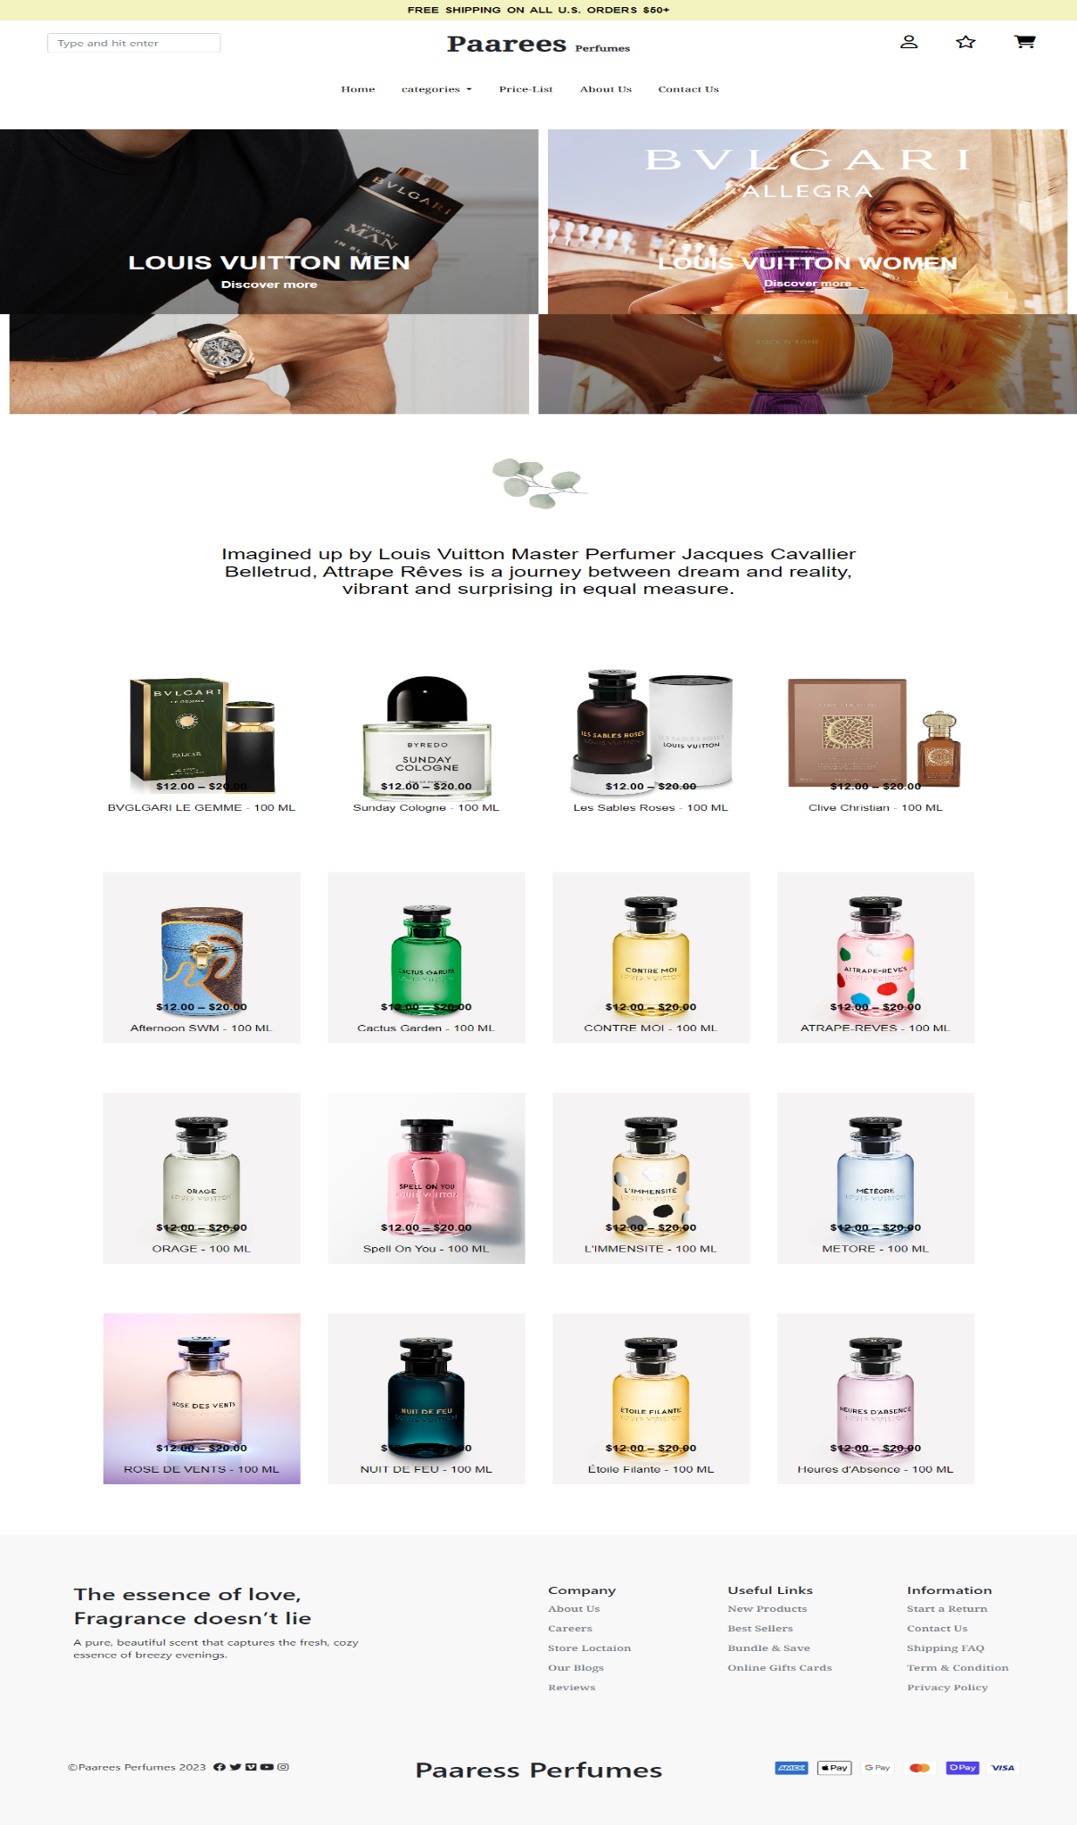

**17**

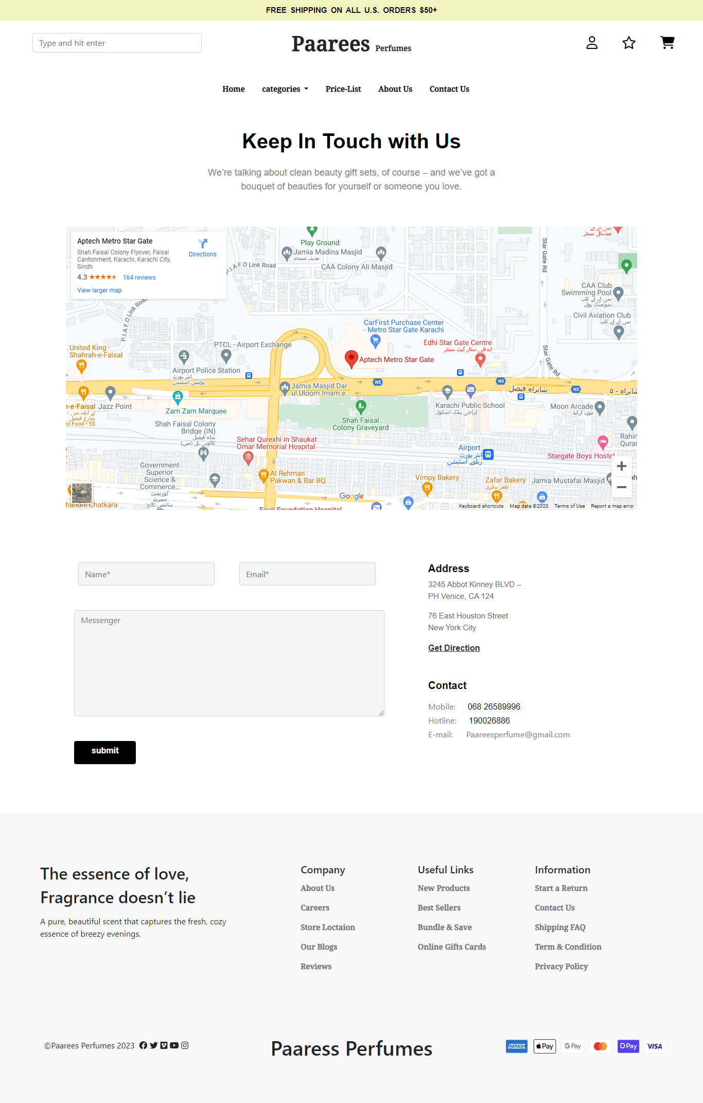

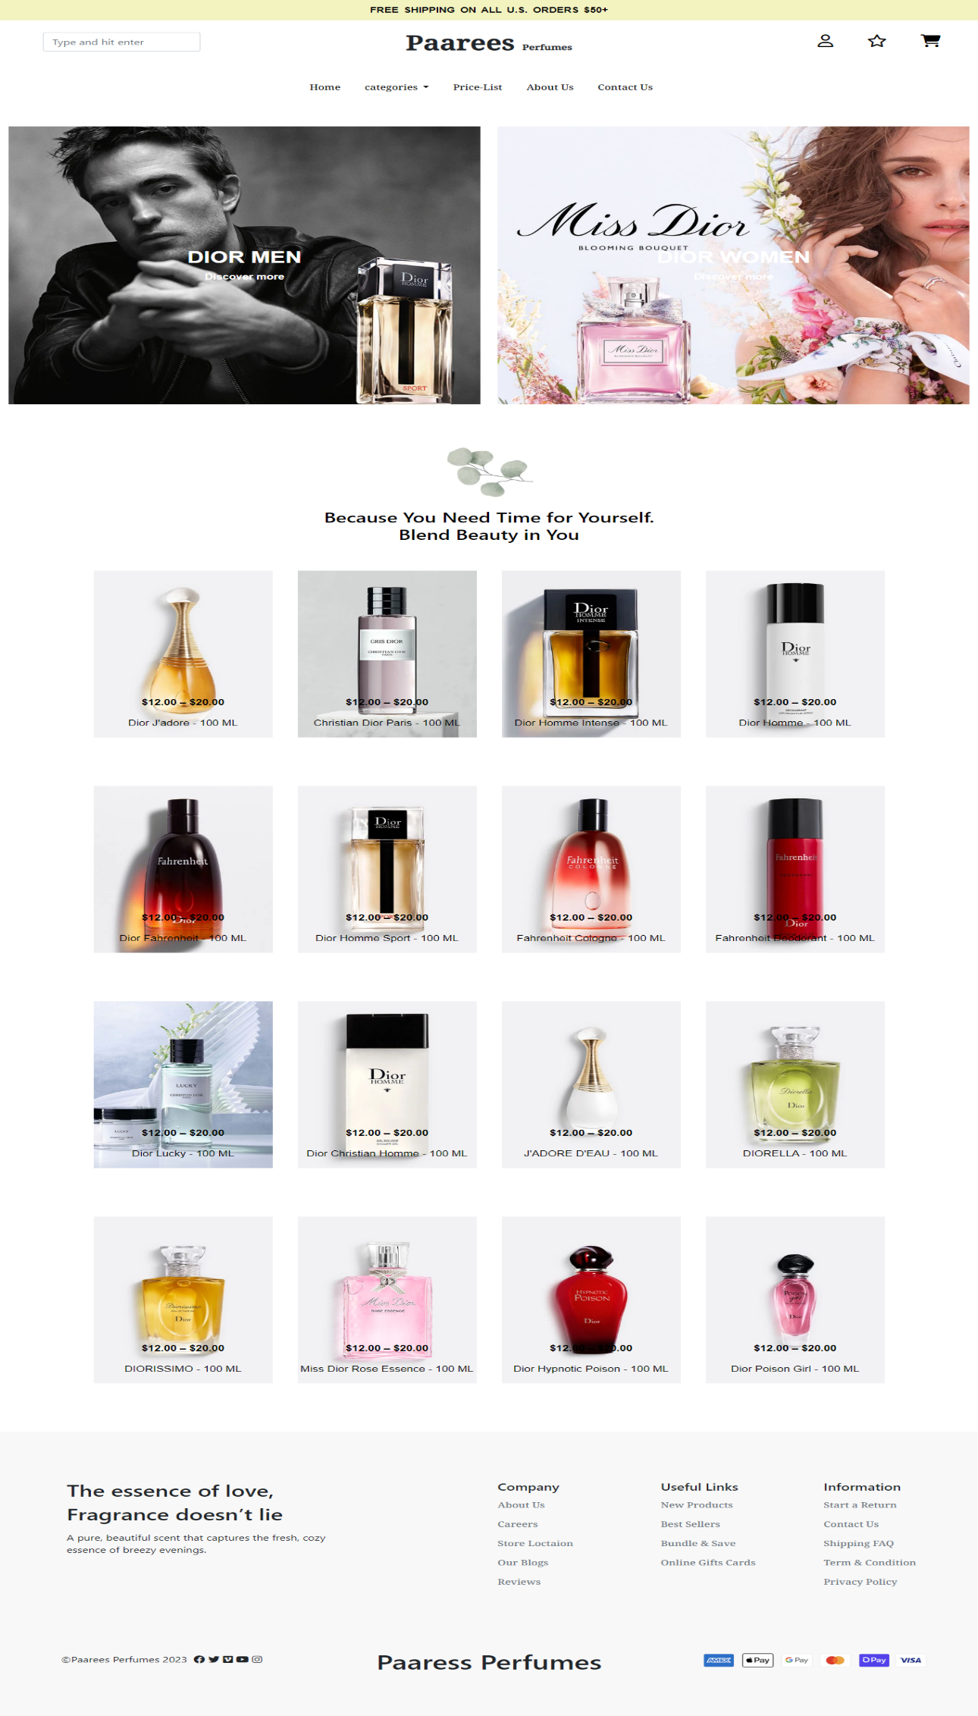

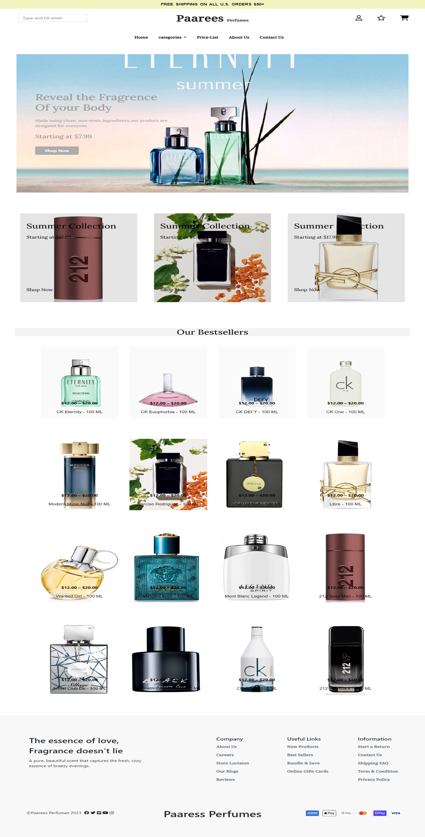

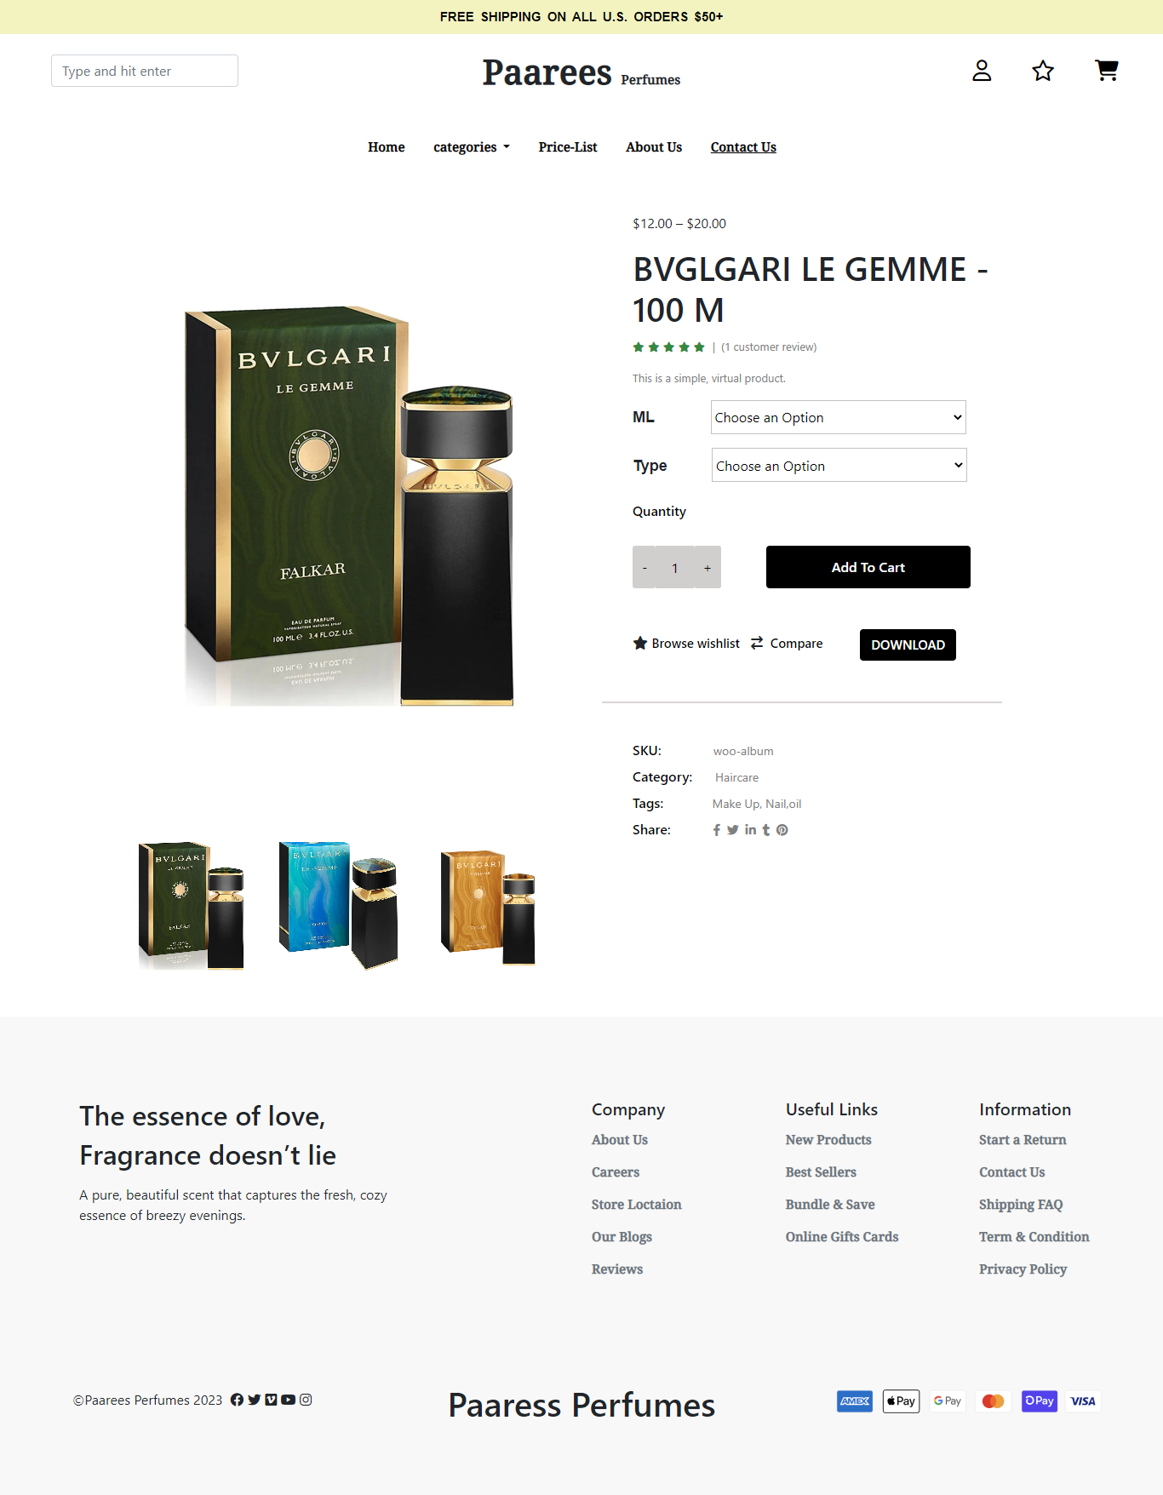

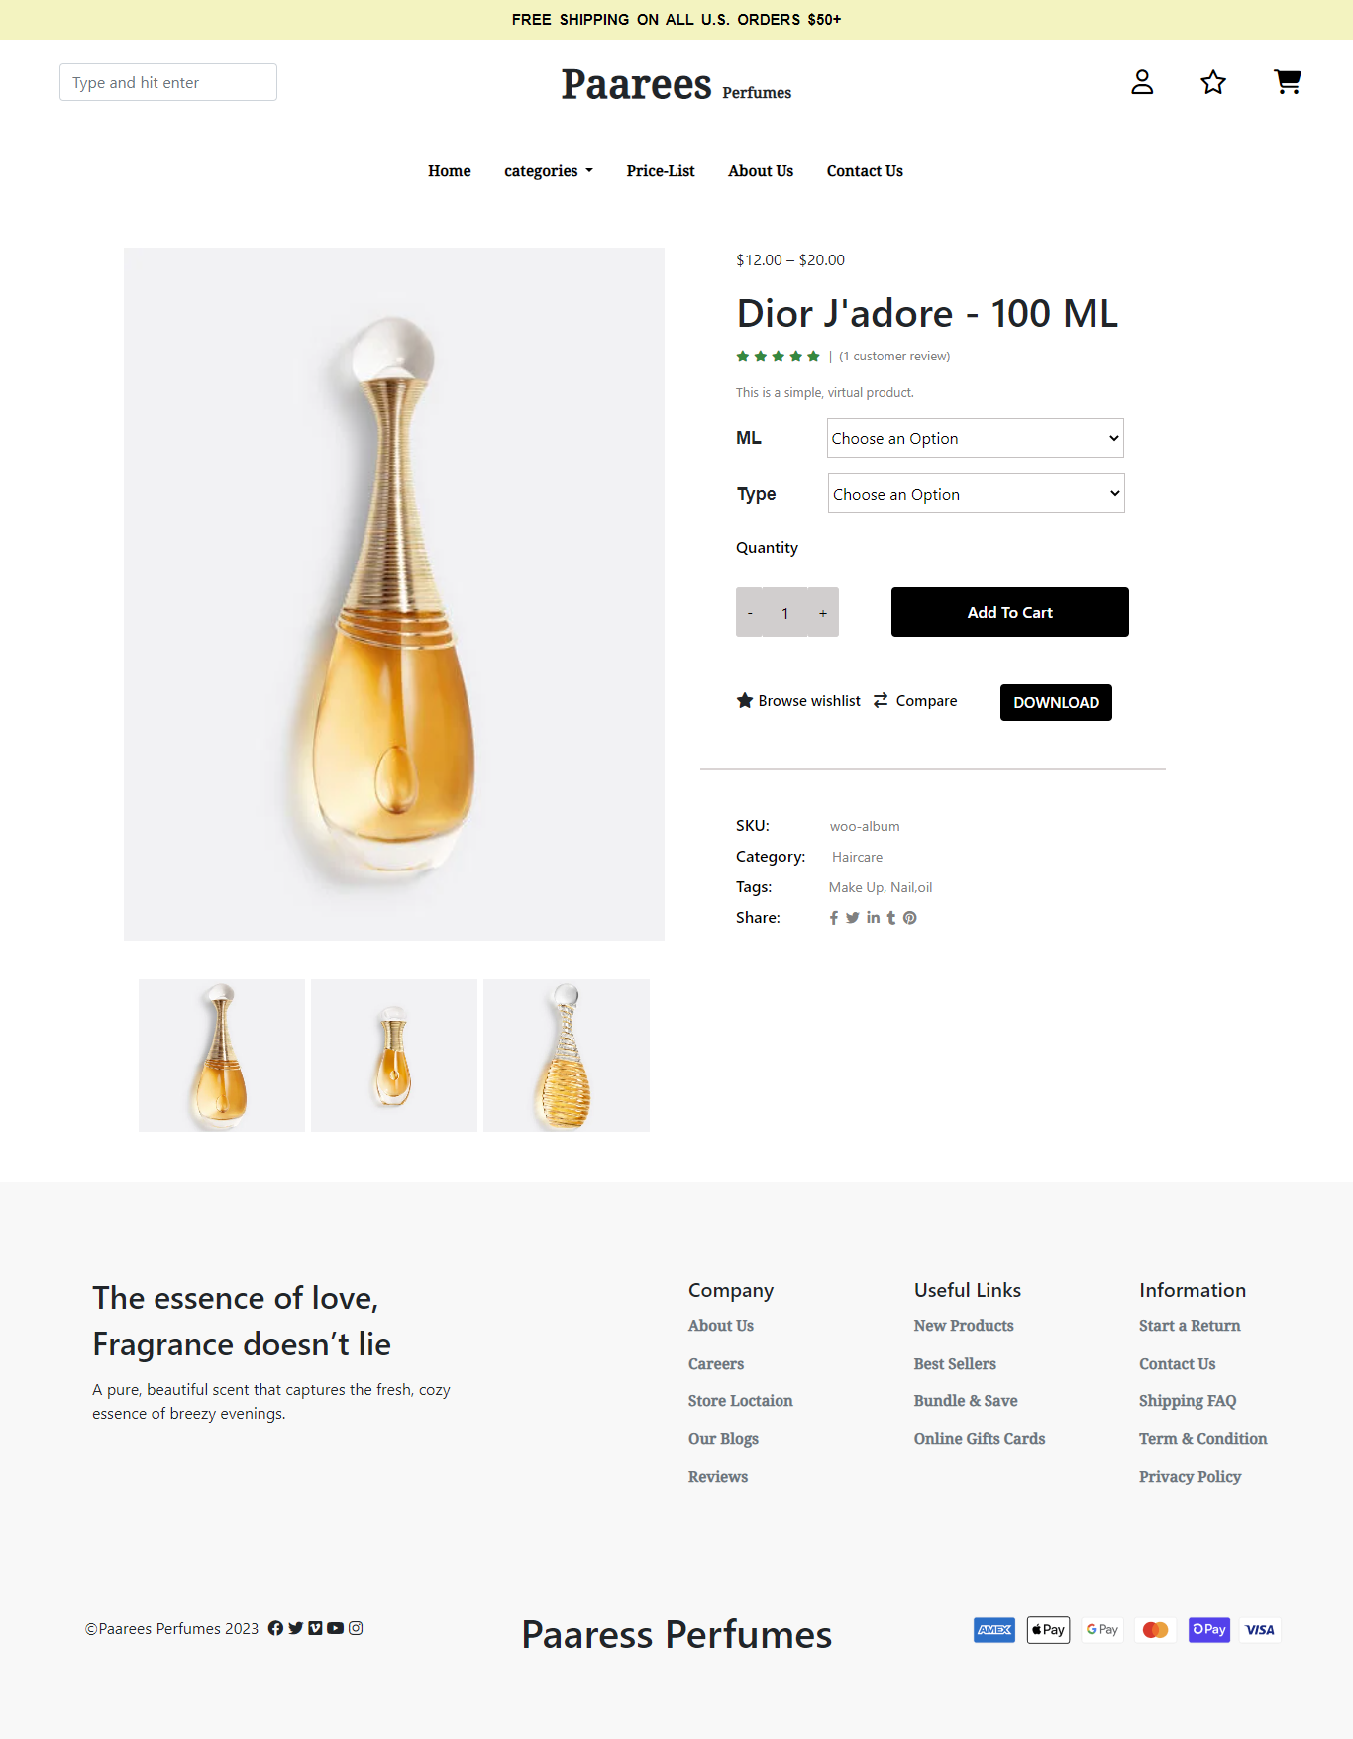

**18**